# Calculus 12

Exam Outline

June 2016

Time: 2 1/2 hours

### Multiple Choice and Full Solution

***Topics:***

Limits

Computing derivatives

Computing anti-derivatives / integrals including integration by substitution

Interpretation of integrals and derivatives

Area under curve

Determining the equation of a tangent/normal

Applications including

* Motion
* Optimization
* Related Rates

*Some questions for practice:*

1. ~~Find the volume formed by rotating the region contained by y = x + 2 and y = 5 - 2x and the indicated axes~~
2. ~~about the x-axis (x-axis)~~
3. ~~about the y-axis (y-axis)~~
4. ~~The inside of a water glass has a parabolic outline and circular cross-section. Calculate the capacity of the glass defined by rotating y = x~~~~2~~~~, from x = 0 to x = 3 about the y-axis.~~
5. ~~Determine the area between the curves:~~

~~y = x~~~~2~~ ~~- 3; y = 3x~~~~2~~ ~~- 11; x = -1 and x = 3.~~

1. Determine the original function given the following derivative:



1. Determine the area between the two functions shown below.



1. The brakes of a car traveling 27 m/s decelerate the car at the rate of **(2t)** m/s2 . If the car is 95 m from a barrier when the brakes are applied, will it hit the barrier? (Your reasoning should be clear)
2. Two runners are traveling cross-country. Chris leaves camp at 9am and heads directly south traveling at an average of 6 km/h. At 10:30 Andrew leaves camp and heads east traveling at an average of 8 km/h. At 12 noon how quickly are the two runners’ positions separating?
3. An orchard owner has statistical records showing that if 25 apple trees are planted, each tree yields 500 apples (on average), while the yield decreases about 10 apples per tree for each additional tree planted. How many trees should be planted for a maximum yield?
4. Determine the exact values of the following integrals. Show all your work.



1. Practice applications (other link)
2. ~~Cumulative Examination Multiple Choice Question Practice (handout)~~
3. page 243 # 34
4. ~~page 298 # 11~~
5. Evaluate the following integrals:

(a) 

(b) 

(c) 

(d) 

(e) 

(f) 

1. Differentiate the following:



1. Determine the equation of the tangent line to:

 at x = -2

17. Given that  determine the  coordinates of the critical values of y.

18. Given: , determine the values of  for which the function  is concave up.

19. Determine the equation of the tangent line to  at the point  given that:

20. ~~Draw a picture of the rotational solid that has a volume described by the integral:~~

a) 

b) 

c) 

~~21. Match the slope fields with their differential equations. Explain your choices.~~

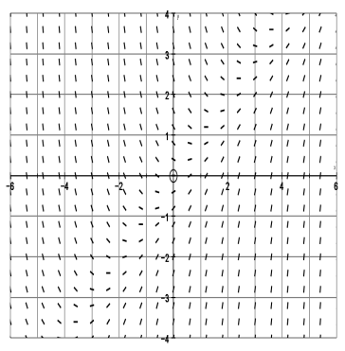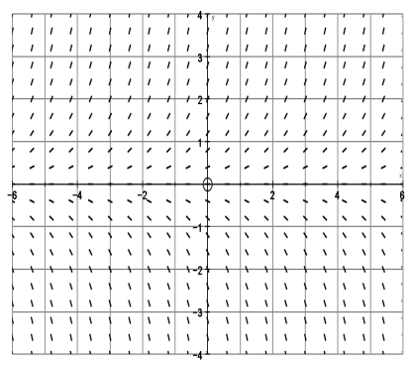



~~22. The calculator drawn slope field for a differential equation is shown below. What do you know about the differential equation that was used to sketch this slope field? Does it contain just x terms, y terms or a combination of both? Explain your reasoning.~~

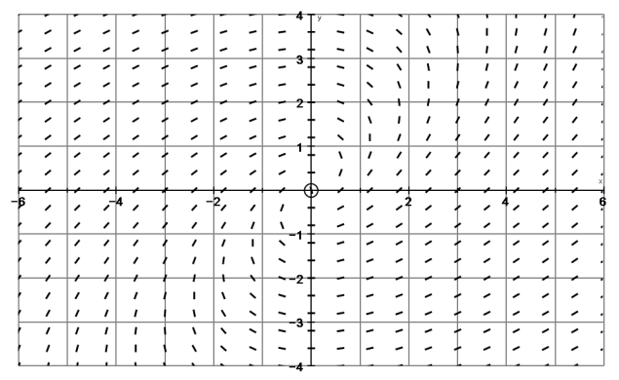

23~~. Determine the area bounded by:~~



24. Suppose that the value of a home in a small city is changing so that its change in value can be expressed by the function:  thousand dollars per year at time t, for 0 < t < 15 years since 1990. Let C(t) denote the cost of a home in the city. If the cost of a home was $72 000 in 1991, find the cost in 2004.

25. Illustrate on the graph below what is meant by . Would you expect it to be positive or negative? Explain your reasoning.

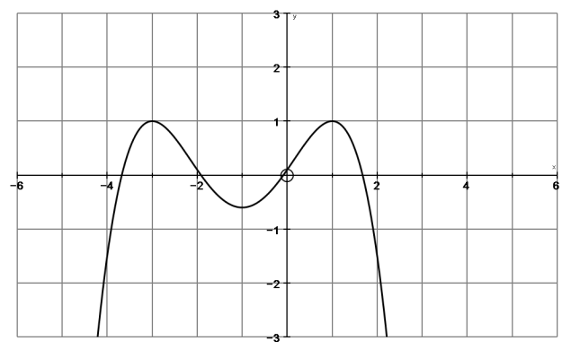

26. If a(t) is measured in apples consumed per week and t is measured in weeks,

a) What are the units of measurement for: 

b) If  what does this mean?

c) If  what does  equal and what does it mean?